 STATISTICS OF IPL USING DATA
VISUALIZATION

A MINI PROJECT REPORT
Submitted by
PADMANABAN V | (721820104032)
VARUN.D | (721820104060)
SHARATH.U | (721820104054)
MESHAL JAFFER | (721820104025)
GOKUL S | (721820104011)

in partial fulfillment for the award of the degree of
BACHELOR OF ENGINEERING
IN
COMPUTER SCIENCE AND ENGINEERING

RATHINAM TECHNICAL CAMPUS
COIMBATORE-641021

ANNA UNIVERSITY: CHENNAI 600025
APRIL 2023
STATISTICS OF IPL USING DATA VISUALIZATION

A MINI PROJECT REPORT
Submitted by
PADMANABAN | (721820104032)
VARUN.D | (721820104060)
SHARATH.U | (721820104054)
MESHAL JAFFER | (721820104025)
GOKUL.S | (721820104011)

in partial fulfillment for the award of the degree of
BACHELOR OF ENGINEERING
IN
COMPUTER SCIENCE AND ENGINEERING

RATHINAM TECHNICAL CAMPUS
COIMBATORE-641021

ANNA UNIVERSITY: CHENNAI 600025
APRIL 2023
BONAFIDE CERTIFICATE
Certified that this project report “STATISTICS OF IPL USING DATA VISUALIZATION” is the bonafide work of “PADNABAN V, VARUN D, SHARATH U, MESHAL JAFFER ,GOKUL S” who carried out the mini project work under my supervision.

SIGNATURE SIGNATURE
Ms. S. KANAKA PRABHA M.Tech Dr. P. ARULPRAKASH M.E., Ph.D.,
Project Guide, Head of the Department,
Computer science and Engineering, Computer science and Engineering,
Rathinam Technical Campus, Rathinam Technical Campus,
Eachanari, Coimbatore-641 021. Eachanari, Coimbatore-641 021.

Submitted for the ANNA UNIVERSITY, Chennai project viva-voce held on ________________________

INTERNAL EXAMINER EXTERNAL EXAMINER

ACKNOWLEDGEMENT
The success of work depends on the team and its cooperation. We take this Opportunity to express our gratitude and sincere thanks to everyone who helped us in our project. First and foremost, we would like to thank the Management for the excellent infrastructure, facilities and the constant support provided for the successful completion for the project work. We wish to express our heartfelt thanks and deep sense of gratitude our chairman Dr. MADAN A SENDHIL M.S.,Ph.D., for his valuable guidance and continuous support.
Our sincere thanks to honorable Principal Dr. B. NAGARAJ M.E., Ph.D., for giving us the opportunity to display our professional skills through this project.
Our special thanks to our HOD Dr. P. ARULPRAKASH M.E., Ph.D., Head of the department of Computer Science and Engineering.
We are greatly thankful to our project coordinator and project guide Ms. KANAKA PRABHA.S, MTech Department of Computer Science and Engineering for her valuable guidance, continuous support, and suggestions to improve the quality of the project work.
We express our deep sense of gratitude to all the faculty members , supporting and non-supporting staff members for their continuous support in completing this project work successfully.

ABSTRACT
The Indian Premier League (IPL) has emerged as one of the most popular and competitive cricket tournaments in the world. This project aims to analyze IPL data using data visualization techniques to uncover meaningful insights and trends. By leveraging statistical methods and visual representations, we seek to provide a comprehensive understanding of the tournament’s performance metrics, team dynamics, and individual player contributions.
The project begins by collecting a rich dataset comprising IPL match statistics, team standings, player profiles, and match outcomes. This dataset is then preprocessed to ensure data integrity and consistency. Key statistical measures such as batting averages, strike rates, bowling economies, and fielding performances are calculated to evaluate player and team performances across different seasons.
Data visualization techniques play a crucial role in this project, enabling us to present complex IPL data in an intuitive and visually appealing manner. Various visualization tools and libraries are employed to create interactive charts, graphs, heatmaps, and geographical maps. These visualizations offer a comprehensive view of player and team statistics, match outcomes, home-ground advantages, and performance trends over time.
Through our statistical analysis and data visualizations, we aim to address several research questions, including identifying the most successful IPL teams, highlighting key player contributions, examining the impact of toss on match outcomes, and exploring the relationship between various performance metrics. The findings from this project can provide valuable insights to cricket enthusiasts, team managers, and decision-makers in the cricketing world.
By combining statistical analysis with data visualization techniques, this project contributes to a deeper understanding of the IPL and facilitates data-driven decision-making. The visual representations serve as effective tools for exploring and communicating complex IPL statistics, enhancing the accessibility and usability of the data for a wide range of users.

TABLE OF CONTENTS

S.NO | TITLE | PAGE NO
01 | Introduction | 06
02 | Literature Survey | 08
03 | Project Basics and Requirements | 10
04 | System Analysis  - Existing system  - Proposed System  - System architecture  Conclusion | 12  14  16  18  19
05 | References  Appendix I | 20  22

LIST OF FIGURES
S.NO | TITLE | PAGE NO
1 | System Architecture | 13
2 | APPENDIX  Season  Player  Match  Player Match | 15  18  19  20
3 | Overall Statistics | 21

CHAPTER-1

INTRODUCTION

The Indian Premier League (IPL) has become a global phenomenon, captivating cricket enthusiasts with its thrilling matches, star-studded teams, and fierce competition. With its vast repository of match data, the IPL presents a unique opportunity for statistical analysis to uncover valuable insights and trends. Data visualization techniques play a crucial role in this analysis by providing intuitive and visually appealing representations of complex data, enabling cricket enthusiasts, team managers, and decision-makers to derive meaningful conclusions.
In this project, we aim to leverage statistical analysis and data visualization to delve into the wealth of IPL data. By examining various performance metrics such as batting averages, strike rates, bowling economies, and fielding statistics, we can gain a comprehensive understanding of player and team performances over different seasons. These statistical measures allow us to quantify and compare the contributions of different players and teams, identifying trends and patterns that may otherwise go unnoticed.
Data visualization techniques bring the IPL data to life, transforming raw numbers into interactive charts, graphs, and maps. With the help of visualization libraries such as Matplotlib, Seaborn, and Plotly, we can create visual representations that aid in the exploration and comprehension of the data. These visualizations allow us to identify outliers, observe correlations between variables, and highlight performance trends over time. By presenting the data in a visually appealing and easily digestible format, data visualization facilitates the communication of insights to a wider audience.
The analysis of IPL data using statistical techniques and data visualization has numerous applications. Team managers can utilize these insights to identify areas of improvement, strategize team compositions, and make informed decisions during player auctions and transfers. Cricket enthusiasts can gain a deeper understanding of the game, appreciate the contributions of different players, and engage in data-driven discussions and debates. Furthermore, stakeholders involved in cricket analytics, broadcasting, and sponsorship can leverage these findings to enhance their understanding of the IPL's impact and make informed business decisions.
Data visualization offers a visual representation of statistical information, transforming complex numbers into intuitive and meaningful visual displays. Through charts, graphs, maps, and interactive visualizations, we can present the statistical data in a way that is easily digestible and enables users to explore the insights more effectively. By leveraging visualization techniques, we can uncover hidden patterns, identify outliers, and gain a deeper understanding of the dynamics of the IPL. Data visualization offers a visual representation of statistical information, transforming complex numbers into intuitive and meaningful visual displays. Through charts, graphs, maps, and interactive visualizations, we can present the statistical data in a way that is easily digestible and enables users to explore the insights more effectively. By leveraging visualization techniques, we can uncover hidden patterns, identify outliers, and gain a deeper understanding of the dynamics of the IPL. Moreover, data visualization brings life to the statistics, making them more engaging and impactful. Visualizations can capture the excitement of the IPL, allowing fans to relive memorable moments, compare player performances, and track team progress. They enable us to tell compelling stories through data, conveying insights and narratives that enhance our understanding of the game.
In conclusion, the combination of statistical analysis and data visualization provides a powerful approach to unravel the intricate patterns and trends within IPL data. By exploring player and team performances, match outcomes, and various performance metrics, we can extract meaningful insights and communicate them effectively through visual representations. This project aims to contribute to a comprehensive understanding of the IPL and its statistical nuances, enabling stakeholders to make data-driven decisions and appreciate the game at a deeper level.

CHAPTER – 2
LITERATURE SURVEY
"Statistical Analysis of IPL Match Results Using Data Mining Techniques” by Mahesh P. Singh and Bhushan D. Patil (2016): This research paper focuses on applying data mining techniques to analyze IPL match results. The study utilizes statistical measures and visualization tools to identify patterns and predict match outcomes. It provides insights into the application of statistical methods in IPL data analysis.

1.“Cricket Analytics: The Power of Data in Game Strategy” by Abhinav Agrawal and Shivam Sharma (2017): This paper explores the role of data analytics in cricket, including the IPL. It discusses the use of statistical analysis and data visualization techniques to derive insights for team strategy, player selection, and performance evaluation. The authors Emphasize the importance of data-driven decision-making in modern cricket.

2.“Exploratory Data Analysis of Indian Premier League” by Gaurav Gupta, Gopesh Tulsyan, and Abhijeet Yadav (2018): This study focuses on exploratory data analysis of IPL data. It employs statistical measures and visualizations to analyze various aspects of the tournament, including team performances, player contributions, and match outcomes. The paper provides insights into the application of data visualization techniques in IPL data analysis.

3.“An Analysis of the Indian Premier League (IPL) from a Cricketing Perspective” by Rahul Bheemanathi and Sai Varshith Reddy (2018): This research paper presents a comprehensive analysis of the IPL from a cricketing perspective. It utilizes statistical techniques to evaluate team and player performances, identify key factors influencing match outcomes, and explore trends over different seasons. The study showcases the importance of statistical analysis in understanding the dynamics of the IPL.
4.“Visual Analytics for Exploring IPL Data” by Manoj K. Chaurasia, Srinath Srinivasa, and Sharath Kumar N. (2020): This paper focuses on the application of visual analytics techniques to explore IPL data. It discusses the use of interactive visualizations to analyze player performances, team dynamics, and match outcomes. The study highlights the role of data visualization in presenting complex IPL data in a user-friendly and comprehensible manner.

5.“Performance Analysis of Players in IPL Using Data Visualization” by Nandini L., Supriya H. R., and Meghana G. (2021): This research paper examines the performance analysis of IPL players using data visualization techniques. It employs visual representations such as bar charts, heatmaps, and scatter plots to showcase player statistics and trends. The study emphasizes the effectiveness of data visualization in presenting player performance data.

These literature sources provide a solid foundation for understanding the application of statistical analysis and data visualization in analyzing IPL data. They showcase the use of various statistical measures and visualization techniques to explore player performances, team dynamics, and match outcomes. By building upon these previous works, this project aims to contribute to the existing body of knowledge by conducting a comprehensive statistical analysis of IPL data using data visualization techniques.

CHAPTER – 3

PROJECT BASICS AND REQUIREMENTS

Project Basics and Requirements:
1. Data Collection: The project requires collecting a comprehensive dataset of IPL match statistics, team standings, player profiles, and match outcomes. This dataset should cover multiple seasons of the IPL and include relevant information such as batting and bowling statistics, fielding performances, match results, and venue details.
2. Data Preprocessing: Once the dataset is collected, it needs to be preprocessed to ensure data integrity and consistency. This may involve handling missing values, removing duplicates, standardizing data formats, and transforming data if necessary.
3. Statistical Analysis: The project involves conducting statistical analysis on the IPL data to derive meaningful insights and trends. This may include calculating various performance metrics such as batting averages, strike rates, bowling economies, and fielding statistics. Statistical methods such as correlation analysis, regression analysis, and hypothesis testing can be applied to explore relationships and patterns within the data.
4. Data Visualization: Data visualization is a key aspect of the project, utilizing various visualization techniques and tools to present IPL data in an intuitive and visually appealing manner. Visualization libraries can be used to create charts, graphs, heatmaps, geographical maps, and interactive visualizations. The visual representations should effectively communicate the statistical findings and facilitate data exploration.
5. Research Questions: The project should address specific research questions related to IPL data. These questions may include identifying the most successful teams, highlighting key player contributions, examining the impact of toss on match outcomes, analyzing home-ground
advantages, and exploring relationships between different performance metrics. The research questions provide a framework for the analysis and visualization tasks.
6. Documentation: It is important to document the entire project, including the dataset description, preprocessing steps, statistical analysis methods employed, visualization techniques used, and findings derived from the analysis. The documentation should be clear, concise, and well-organized, enabling others to understand and reproduce the project.
7. Presentation and Communication: The project should culminate in a presentation or report that effectively communicates the insights and findings derived from the IPL data analysis. The presentation/report should include visualizations, key statistical findings, interpretations, and recommendations based on the analysis.
8. Programming Skills: Proficiency in programming languages such as Python is essential for data preprocessing, statistical analysis, and data visualization tasks. Familiarity with relevant libraries and frameworks, such as pandas, numpy, and data visualization tools like Matplotlib, Seaborn, and Plotly, is important.
9. Analytical Skills: Strong analytical skills are crucial for conducting statistical analysis, interpreting the results, and deriving meaningful insights from the IPL data. The ability to apply statistical methods appropriately, identify patterns and trends, and make data-driven conclusions is essential.
10. Domain Knowledge: A basic understanding of cricket and familiarity with the IPL tournament structure, player roles, and game rules is beneficial for contextually analyzing the IPL data and interpreting the statistical findings accurately.
By fulfilling these project basics and requirements, you can undertake a comprehensive statistical analysis of IPL data using data visualization techniques, providing valuable insights into player and team performances, match outcomes, and overall trends within the tournament.

CHAPTER – 4

SYSTEM ANALYSIS

System analysis involves evaluating the requirements, functionalities, and feasibility of a system. In the context of analyzing IPL statistics using data visualization, the following aspects can be considered in system analysis:

1. Requirements Analysis:
- Identify the specific requirements of the system, such as the types of statistics to be analyzed, the visualization techniques to be employed, and the target audience for the visualizations.
- Understand the scope of the project, including the IPL seasons to be considered, the level of detail required in the statistics, and the interactivity desired in the visualizations.

2. Data Collection and Integration:
- Determine the data sources for IPL statistics, such as official IPL websites, cricket databases, or APIs.
- Assess the feasibility of integrating external data sources, such as player profiles, match commentary, or social media data, to enrich the statistical analysis and visualization.

3. Data Preprocessing and Cleaning:
- Define the preprocessing steps required for the IPL data, such as handling missing values, standardizing formats, and resolving inconsistencies.
- Consider data cleaning techniques to address outliers or errors that may affect the accuracy of the statistical analysis and visualizations.

4. Statistical Analysis Techniques:
- Evaluate the statistical analysis techniques to be applied, such as calculating batting averages, strike rates, or creating rankings.
- Assess the relevance and suitability of advanced statistical methods, such as regression analysis or clustering, for extracting deeper insights from the IPL data.

5. Visualization Techniques and Tools:
- Select appropriate data visualization techniques, such as bar charts, line graphs, scatter plots, heatmaps, or interactive dashboards, based on the requirements and target audience.
- Consider visualization libraries or tools like Matplotlib, Plotly, Tableau, or D3.js to implement the chosen visualizations effectively.

6. User Interface Design:
- Design an intuitive and user-friendly interface for the visualization system, allowing users to interact with and explore the IPL statistics.
- Incorporate interactive features like filtering, zooming, or drill-down options to enhance user engagement and facilitate detailed analysis.

7. Performance Analysis:
- Analyze the performance requirements of the system, including response time, scalability, and computational efficiency for handling large volumes of IPL data.
- Optimize the data processing and visualization pipelines to ensure smooth and efficient performance of the system.

8. Documentation and Reporting:
- Establish documentation practices to record the specifications, methodologies, and steps involved in the statistical analysis and visualization.
- Create user guides or documentation that explains the functionality of the system, interpretation of the visualizations, and insights derived from the IPL statistics.

By conducting a thorough system analysis, the system for analyzing IPL statistics using data visualization can be designed to meet the requirements and expectations of users. It ensures the feasibility, efficiency, and usability of the system, allowing stakeholders to gain valuable insights from the IPL statistics and make data-driven decisions effectively.

The existing system for IPL data analysis and visualization typically involves manual data collection, limited statistical analysis, and basic visualization capabilities. Here are the key components of the existing system:

A. EXISTING SYSTEM
1. Manual Data Collection:
- In the existing system, data collection is typically performed manually by individuals who gather IPL match statistics, team standings, player profiles, and match outcomes from various sources such as websites, databases, or official records.
- The process of collecting and compiling the data may be time-consuming and prone to errors, especially when dealing with large datasets spanning multiple seasons.

2. Limited Statistical Analysis:
- The existing system often lacks comprehensive statistical analysis capabilities. Basic statistical measures like batting averages and bowling economies may be calculated manually, but more complex analyses and calculations are generally not performed.
- The absence of robust statistical techniques and tools limits the depth and accuracy of insights that can be derived from the IPL data.

3. Basic Visualization:
- Data visualization in the existing system is typically limited to basic charts, such as bar charts or line graphs, created manually using spreadsheet software.
- The visualizations may lack interactivity, making it difficult for users to explore the data and uncover meaningful patterns or trends.
- Limited graphical representations may hinder the effective communication of insights and findings derived from the IPL data analysis.

4. Lack of Automation and Efficiency:
- The existing system heavily relies on manual data entry and analysis, which can be time-consuming and error-prone.
- Data preprocessing tasks, such as handling missing values or data inconsistencies, are not automated, leading to inefficiencies in data management and analysis.

5. Limited Integration:
- The existing system often lacks integration with other data sources or systems, limiting the scope and comprehensiveness of the IPL data analysis.
- Integration with external databases, APIs, or real-time data feeds is typically absent, hindering the ability to access up-to-date and diverse data for analysis.

6. Minimal Documentation:
- Documentation of the existing system may be minimal or inconsistent, making it challenging to understand the data sources, preprocessing steps, and analysis methodologies employed.
- Inadequate documentation hampers the reproducibility of the analysis and impedes knowledge sharing and collaboration.

Overall, the existing system for IPL data analysis and visualization is characterized by manual data collection, limited statistical analysis capabilities, basic visualization techniques, and a lack of automation and efficiency. These limitations can restrict the depth and accuracy of insights derived from the IPL data and hinder effective decision-making in the cricketing context.

- PROPOSED SYSTEM:
The proposed system aims to overcome the limitations of the existing system by introducing automation, advanced statistical analysis techniques, interactive data visualization, and improved integration capabilities. Here are the key components of the proposed system:
1. Automated Data Collection:
- Implement automated data collection processes that retrieve IPL match statistics, team standings, player profiles, and match outcomes from reliable sources such as APIs or databases. - Ensure regular updates of the dataset to incorporate new IPL seasons and maintain data accuracy and relevance.
2. Comprehensive Statistical Analysis:
- Employ advanced statistical analysis techniques to calculate a wide range of performance metrics, including batting averages, strike rates, bowling economies, fielding statistics, and more.
- Apply statistical methods such as correlation analysis, regression analysis, and hypothesis testing to explore relationships, identify patterns, and derive meaningful insights from the IPL data.
3. Interactive Data Visualization:
- Utilize powerful data visualization libraries and tools such as Matplotlib, Seaborn, Plotly, or Tableau to create interactive and visually appealing visualizations.
- Develop a variety of visual representations, including charts, graphs, heatmaps, geographical maps, and interactive dashboards, enabling users to explore and analyze the IPL data in an intuitive and engaging manner.
- Incorporate interactive features such as filtering, zooming, and drill-down capabilities to enhance the user experience and facilitate in-depth exploration of the data.

4. Automation and Efficiency:
- Implement automated data preprocessing tasks, such as handling missing values, duplicates, and data inconsistencies.
- Integrate data cleaning and transformation techniques to streamline the data management process and ensure data integrity.
- Leverage data automation tools and scripts to optimize data processing and analysis, reducing manual efforts and increasing efficiency.
5. Enhanced Integration:
- Integrate the proposed system with external data sources, databases, or APIs to augment the IPL dataset with additional relevant information.
- Enable real-time data integration to access up-to-date IPL data, allowing for more accurate and timely analysis.
6. Comprehensive Documentation:
- Develop comprehensive documentation that outlines the project specifications, data sources, preprocessing steps, statistical analysis methodologies, and visualization techniques employed.
- Provide clear instructions and guidelines to facilitate reproducibility and knowledge sharing among users and developers.
By implementing the proposed system, IPL data analysis and visualization will benefit from automated processes, advanced statistical analysis techniques, interactive visualizations, improved integration capabilities, and comprehensive documentation. These enhancements will enable stakeholders to gain deeper insights into player and team performances, match outcomes, and overall trends within the IPL, supporting data-driven decision-making and fostering a better understanding of the tournament.

A. SYSTEM ARCHITECTURE:

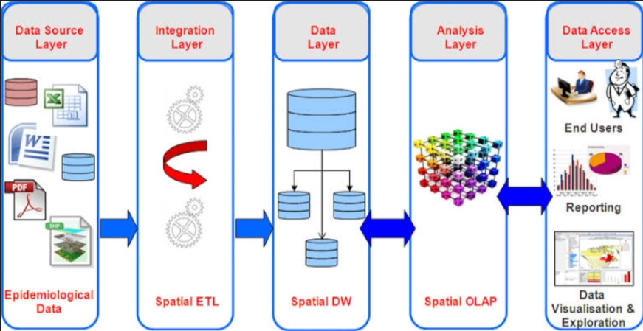
Fig.2: System Architecture

CONCLUSION AND FUTURE ENHANCEMENTS

The proposed system for IPL data analysis and visualization provides an improved and automated approach to analyzing and visualizing IPL data. By incorporating automated data collection, comprehensive statistical analysis, interactive data visualization, integration capabilities, and documentation, the system offers enhanced insights into player and team performances, match outcomes, and overall trends within the IPL.
Through automated data collection processes, the system ensures the regular and accurate retrieval of IPL data from reliable sources. The data is then preprocessed to ensure integrity and consistency, followed by comprehensive statistical analysis techniques that derive
meaningful insights and patterns from the data. Interactive data visualization techniques enable users to explore and understand the IPL data in an intuitive and visually appealing manner.
The system's integration capabilities enable the incorporation of external data sources, databases, or APIs, ensuring the availability of up-to-date and diverse data for analysis. Documentation practices provide transparency and reproducibility, facilitating knowledge sharing and collaboration among users and developers.
These future enhancements would further enrich the IPL data analysis and visualization system, providing more sophisticated analysis, real-time insights, and improved user experiences. They would empower stakeholders with advanced tools and techniques to make data-driven decisions, gain competitive advantages, and enhance their understanding of the IPL and its dynamics.

REFERENCES
1.Erl, T., Khattak, W., & Buhler, P. (2016). Big data fundamentals: Concepts, drivers and techniques.Boston: Prentice Hall.
2.Friendly, M. & Denis, D. J. (2001). Milestones in the history of thematic cartography, statistical graphics, and data visualization. Retrieved from
3.Knaflic, C. N. (2015). Storytelling with data: A data visualization guide for business professionals. Hoboken, N.J.: Wiley
4.Meloncon, L., & Warner, E. (2017). Data visualizations: A literature review and opportunities.for technical and professional communication. Paper presented at the Professional Communication Conference (ProComm), 2017 IEEE International, Madison, WI, USA
5.National Eye Institute. (2015). Facts about color blindness. Retrieved from
6.Shneiderman, B. (1996). The eyes have it: A task by data type taxonomy for information
Visualizations. Paper presented at the Proceedings of IEEE Symposium on Visual Languages
7.Ward, M. O., Grinstein, G., & Keim, D. (2015). Interactive data visualization: Foundations,
Techniques, and applications. Retrieved from
8.Wikipedia. (2017). Information visualisation. Retrieved from

CHAPTER 5
APPENDIX I

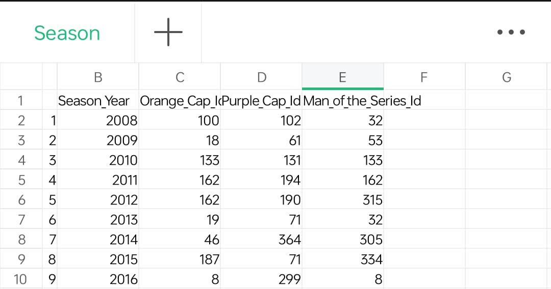

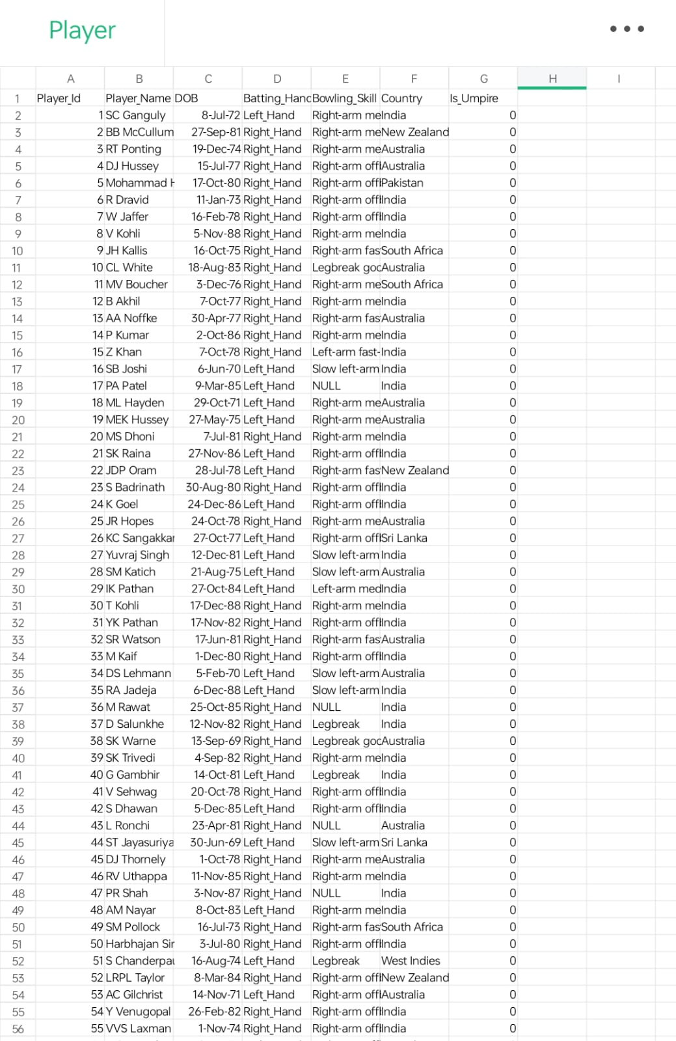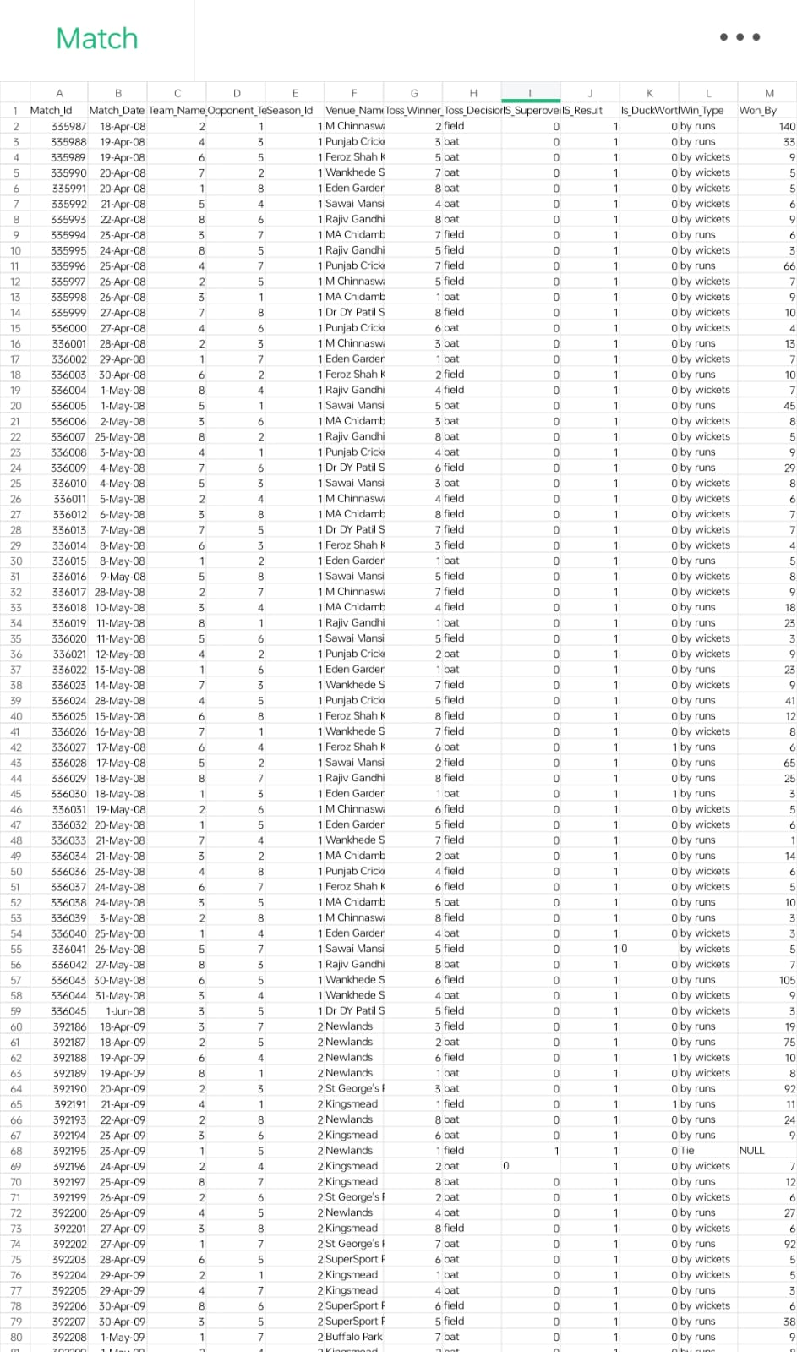
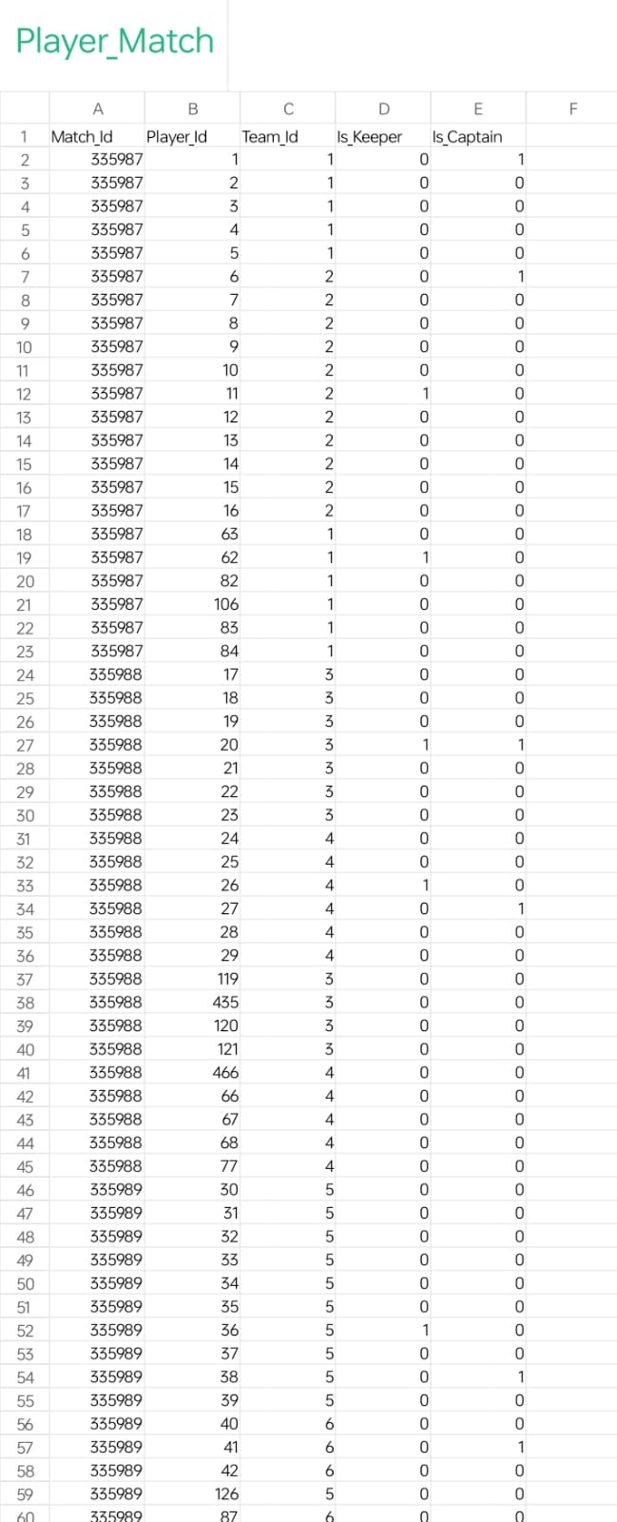

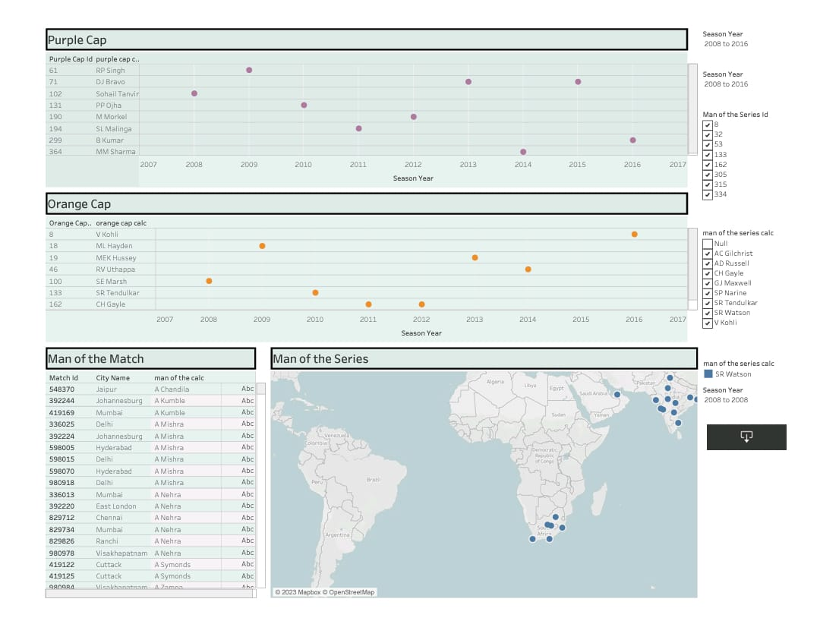
OVERALL IPL STATISTICS

CONFERENCE CERTIFICATE

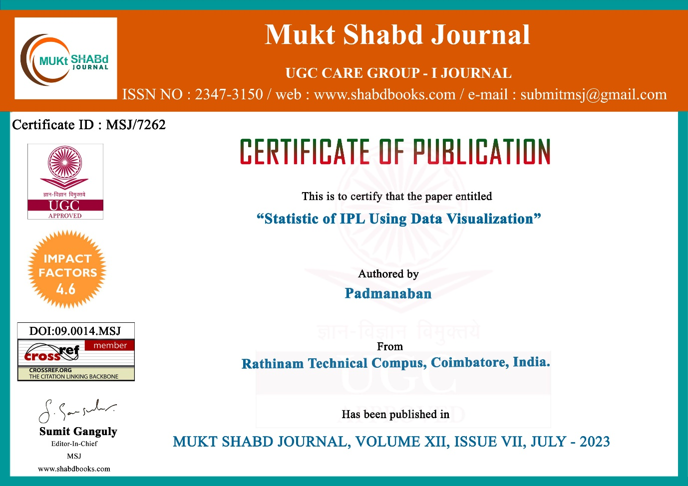

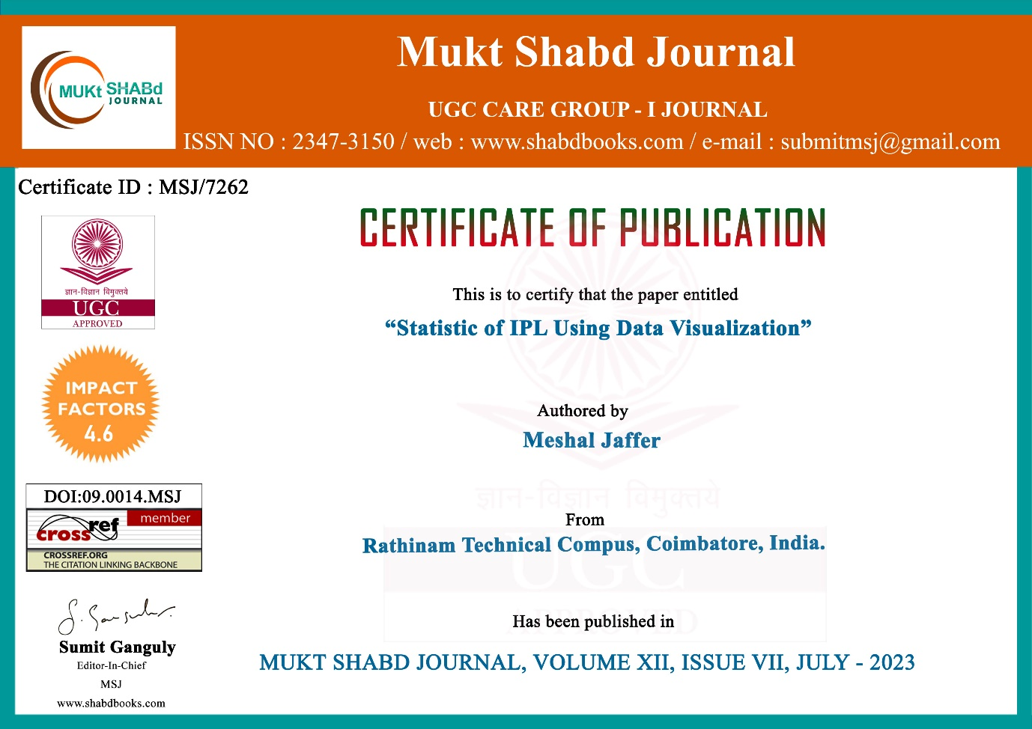

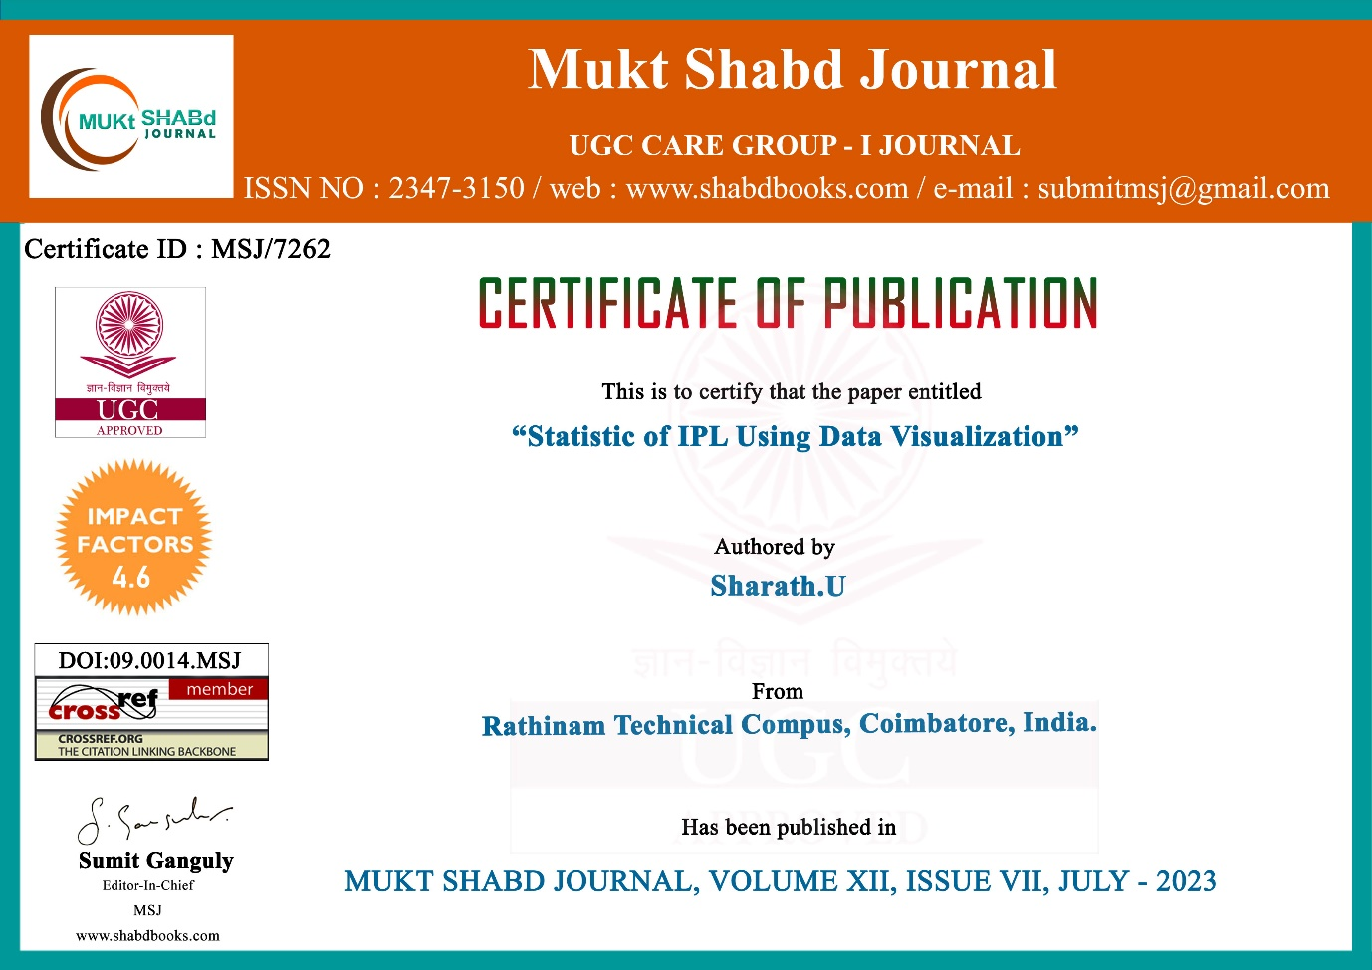

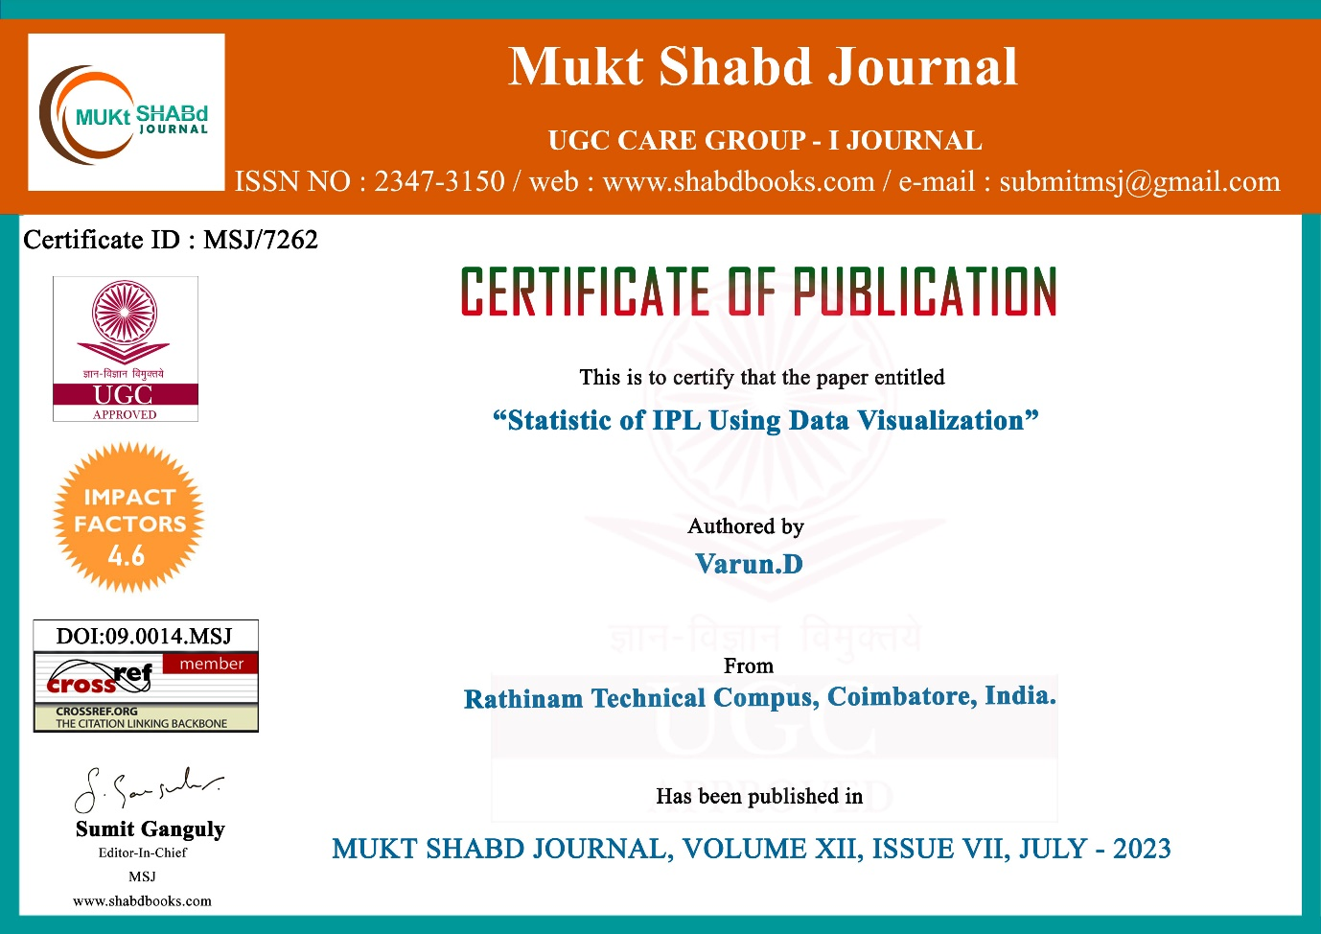

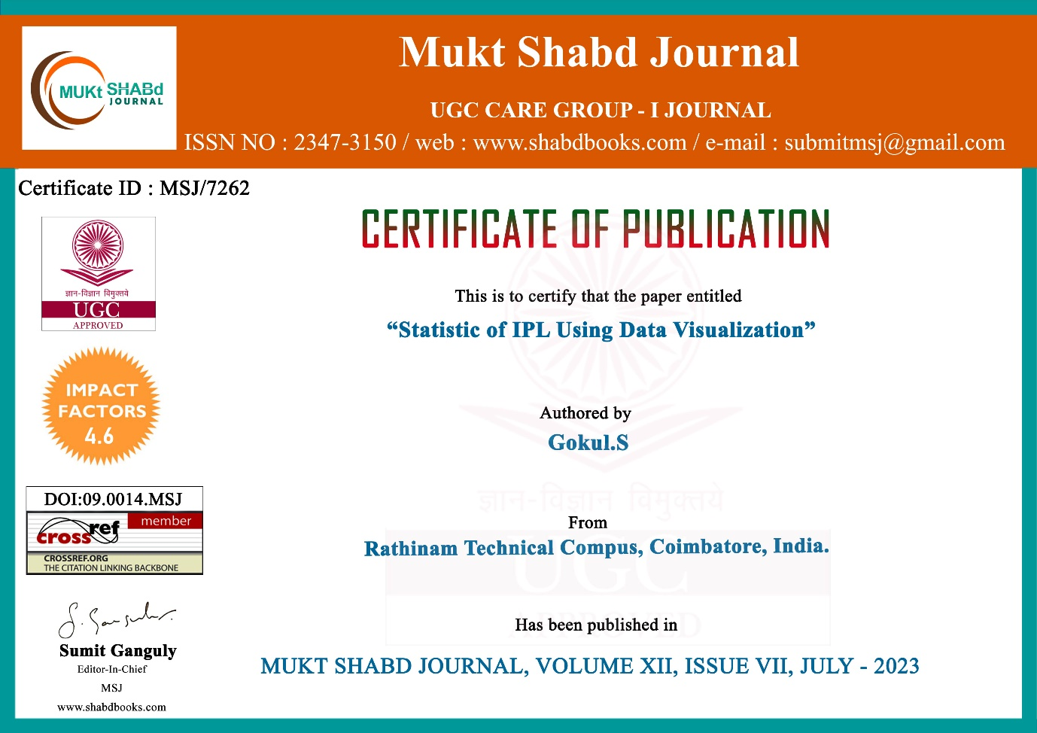

PUBLISHED PAPER

Statistic of IPL

Domain: Data Visualization

Padmanaban , Meshal Jaffer, Sharath.U, Varun.D, Gokul.S , Kanakaprabha.S

UG- Students, Department of Computer Science Engineering, Rathinam Technical Campus, Coimbatore-641021, India

⁶Assistant Professor, Department of Computer Science Engineering, Dept.of Computer Science and Engineering, Rathinam Technical Campus,Coimbatore-641021, India

Abstract
Research on data visualization is undergoing major developments in a number of different fields. These developments include investigating ways of applying visualization techniques and systems for the more efficient manipulation, interpretation and presentation of data. In the built environment field, the potential of new visualization technologies to enhance the presentation of performance data obtained as output from simulation programs has remained almost unexplored. The primary aim of the work summarized in this paper was to commence the development of a method for visualizing the data produced by thermal analysis tools. Two applications are presented. The first is designed to automatically process the output within a commercial spreadsheet program. The second is designed to display the solution in 3D to aid spatial recognition and data navigation. This paper shows, through small-scale user tests, that each of the proposed applications significantly improves some of the attributes associated with usability, namely: learnability, efficiency, memorability, errors and user satisfaction. Advice is given on the key aspects that will require attention when the full method is developed. Finally, it should be possible to develop low-cost data visualization tools to improve the overall usability of a thermal analysis tool within a built environment practice.

DATA VISUALIZATION

INTRODUCTION
Data visualization is the graphical representation of information and data. by using visual elements like charts, graphs, and maps, data visualization tools provide an accessible way to see and understand trends, outliers, and patterns in data. additionally, it provides an excellent way for employees or business owners to present data to non-technical audiences without confusion. in the world of big data, data visualization tools and technologies are essential to analyze massive amounts of information and make data-driven decisions. data visualization is commonly used to spur idea generation across teams. they are frequently leveraged during brainstorming or design thinking sessions at the start of a project by supporting the collection of different perspectives and highlighting the common concerns of the collective. while these visualizations are usually unpolished and unrefined, they help set the foundation within the project to ensure that the team is aligned on the problem that they’re looking to address for key stakeholders. data visualization is a critical step in the data science process, helping teams and individuals convey data more effectively to colleagues and decision makers. teams that manage reporting systems typically leverage defined template views to monitor performance. however, data visualization isn’t limited to performance dashboards. for example, while text mining an analyst may use a word cloud to capture key concepts, trends, and hidden relationships within this unstructured data. alternatively, they may utilize a graph structure to illustrate relationships between entities in a knowledge graph. there are a number of ways to represent different types of data, and it’s important to remember that it is a skillset that should extend beyond your core analytics team.

LITERATURE REVIEW

Adopt a consistent visual language
Enterprises should embrace a consistent application of visual language, said Dan Lawyer, chief product officer at Lucid Software, a virtualization tool provider. For example, a particular shape could always communicate a specific concept. This allows for faster understanding and more clarity in communication. In addition, directly associating the visualization and data can help organize the data into clear and accessible buckets. A proper visual language with direct connections to the data makes it easier to analyze complex webs of data through simplified visuals.

Digitize metrics
Digitization and data collection are crucial to cultivating data visualization literacy, Silipo said. The more data is collected and organized, the more teams can visualize and collaborate around data .One aspect of this step consists of defining KPIs and metrics for consistently measuring processes and events that may not seem easy to quantify. This forms the backbone that makes it easy to choose and apply the appropriate data visualization technique to a given question, analysis or discussion. "Every business problem and every data set shines at its best with the appropriate data visualization technique," Silipo said.

Set up a feedback loop
With data visualization, most of the responsibility is on creators to adjust their visualization, much like book writers adapt their language to the audience. The way they present the data must be understandable by consumers. Quick data analysis and visualization feedback loops can help improve everyone's skills at creating and consuming visualizations, said Marcin Bartoszek, head of business intelligence at space lift ,an infrastructure-as-code platform for DevOps engineers. In the requirements gathering phase, the analyst needs to understand what needs to be done and present an initial data analysis design, including the visualization. The stakeholder can then learn about the methods, give input and learn how to interpret the data. The analyst can then adjust the level of complexity based on the feedback.

Effective Data Storytelling: How to Drive Change with Data, Narrative, and Visuals by Brent Dykes
Data storytelling skills are becoming table stakes for anyone presenting on data. Often called the “last mile of analytics”, data storytelling provides a framework for breaking down data insights to technical and non-technical audiences alike. In his seminal book, Brent Dykes breaks down the value behind data storytelling and the key components of a successful data story. According to Dykes—who appeared on data framed podcast—rather than focusing exclusively on how to visualize data, we should also leverage narrative and storytelling to drive decisions out of insights. In his book, Dykes developed a framework for data storytelling, an approach that combines three central elements: data, narrative, and visuals.

A Data Visualization Guide for Business Professionals by Cole Nussbaumer Knaflic
In the same vein, Cole Nussbaumer Knaflic’s book on Storytelling with Data breaks down the different ways to deliver a data story. Visualizations provide the visual layer to our data stories when working with data. However, how to present and speak effectively through data to tell a compelling story is not an easy task. Bridging this gap is precisely what Cole Nussbaumer Knaflic attempts to do with her book. Storytelling with Data is filled with practical resources and case studies for business and data practitioners looking to use data visualizations effectively. Whether deciding which charts to use, how to structure a data story, or how to declutter a graph, the combination of theory and practice makes the book a great resource for both novel and advanced data visualizations practitioners.

Displaying Data for At-a-glance Monitoring by Stephen Few
Dashboards are the most effective ways to provide at-a-glance views of complex data landscapes. However, dashboards can easily be designed in cumbersome and inefficient ways. The goal of information dashboard design by Stephen Few is to help practitioners avoid common mistakes and traps when developing their dashboards Conceived as a practical guide, the book presents best practices when designing dashboards. It goes into great detail, providing many examples to illustrate both effective and ineffective dashboards and how to avoid common dashboard design pitfalls. In addition to explaining how to create great dashboards, Stephen Few offers a valuable introduction to the principles of design theory and data visualization in the light of recent advancements in the field of neuroscience.

The Accidental Analyst by Eileen Mcdaniel and Stephen McDaniel
As data volumes grow and invade more and more jobs, more professionals—irrespective of their backgrounds—are having to work with data in their day-to-day. If you see yourself as an accidental analyst who didn’t plan to work with and analyze data in their role, this book is for you.The by Eileen Mcdaniel and Stephen McDaniel provides an intuitive, step-by-step framework to address the complexities of data analysis and visualization. The so-called “Seven C's of Data Analysis” define a straightforward course of action to accidental analysis successfully organize, analyze and visualize data following industry best practice.

METHODOLOGY
Data set description
Flowchart , Algorithm

Proposed Methodology
Data visualization is the graphical representation of information and data. By using visual elements like charts, graphs, and maps, data visualization tools provide an accessible way to see and understand trends, outliers, and patterns in data. That’s where data visualization comes in handy. With the goal of making data more accessible and understandable, data visualization in the form of dashboards is the go-to tool for many businesses to analyze and share information.

A Short History of Data Visualization
A brief walk through some of the main innovations and innovators in turning numbers into pretty pictures with modern technology, visualizing data has never been easier. A few clicks of the mouse, can more or less instantly turn a huge table of raw numbers into a visually appealing and easy to interpret diagram. Graphing data provides a high-speed shortcut to creating understanding and getting your point across. Many of the visualization techniques of today were invented during the industrial revolution, with the field making large strides in the mid-19th century. What may seem simple and obvious today, such as a bar chart or line graph, would have been strange and unfamiliar to someone 200 years ago. In this article we take a look at some of the major innovators in the graphical representation of data and some of their famous works.
Data visualization has a long and dynamic history. From the early days of cave paintings and ancient hieroglyphics to the Renaissance period's charts and diagrams, humans have always sought ways to visually represent data. However, it was in the 19th century that pioneers like Florence Nightingale and William Playfair made significant contributions to the field. The 20th century saw a revolution with the advent of computer technology, enabling more complex and interactive visualizations. Jacques Bertin and Edward Tufte further advanced the principles and techniques of data visualization. With the rise of the internet and digital technologies, data visualization has become more accessible and pervasive, playing a critical role in diverse fields. Today, we continue to witness exciting developments in the field, fueled by emerging technologies like virtual reality and augmented reality.

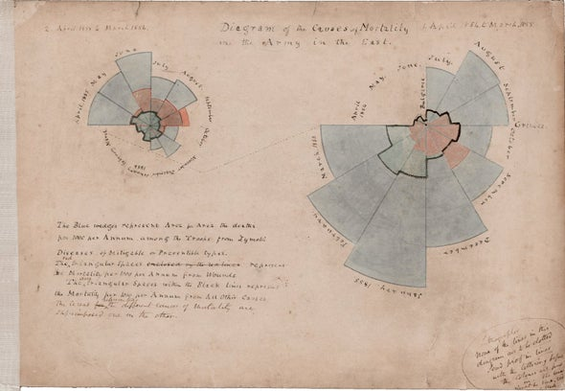
SURVIVING DRAFTS OF NIGHTINGALE'S

RESULT AND ANALYSIS
It represent the detailed view of the Indian premier league(IPL). it shows the best player of the match and it represent the best blower and it represent the best player of the tournament and show the highest wicket taker and the highest run scorer. and they can be filtered by the preference of the user

OUTPUT OF THE DASHBOARD:

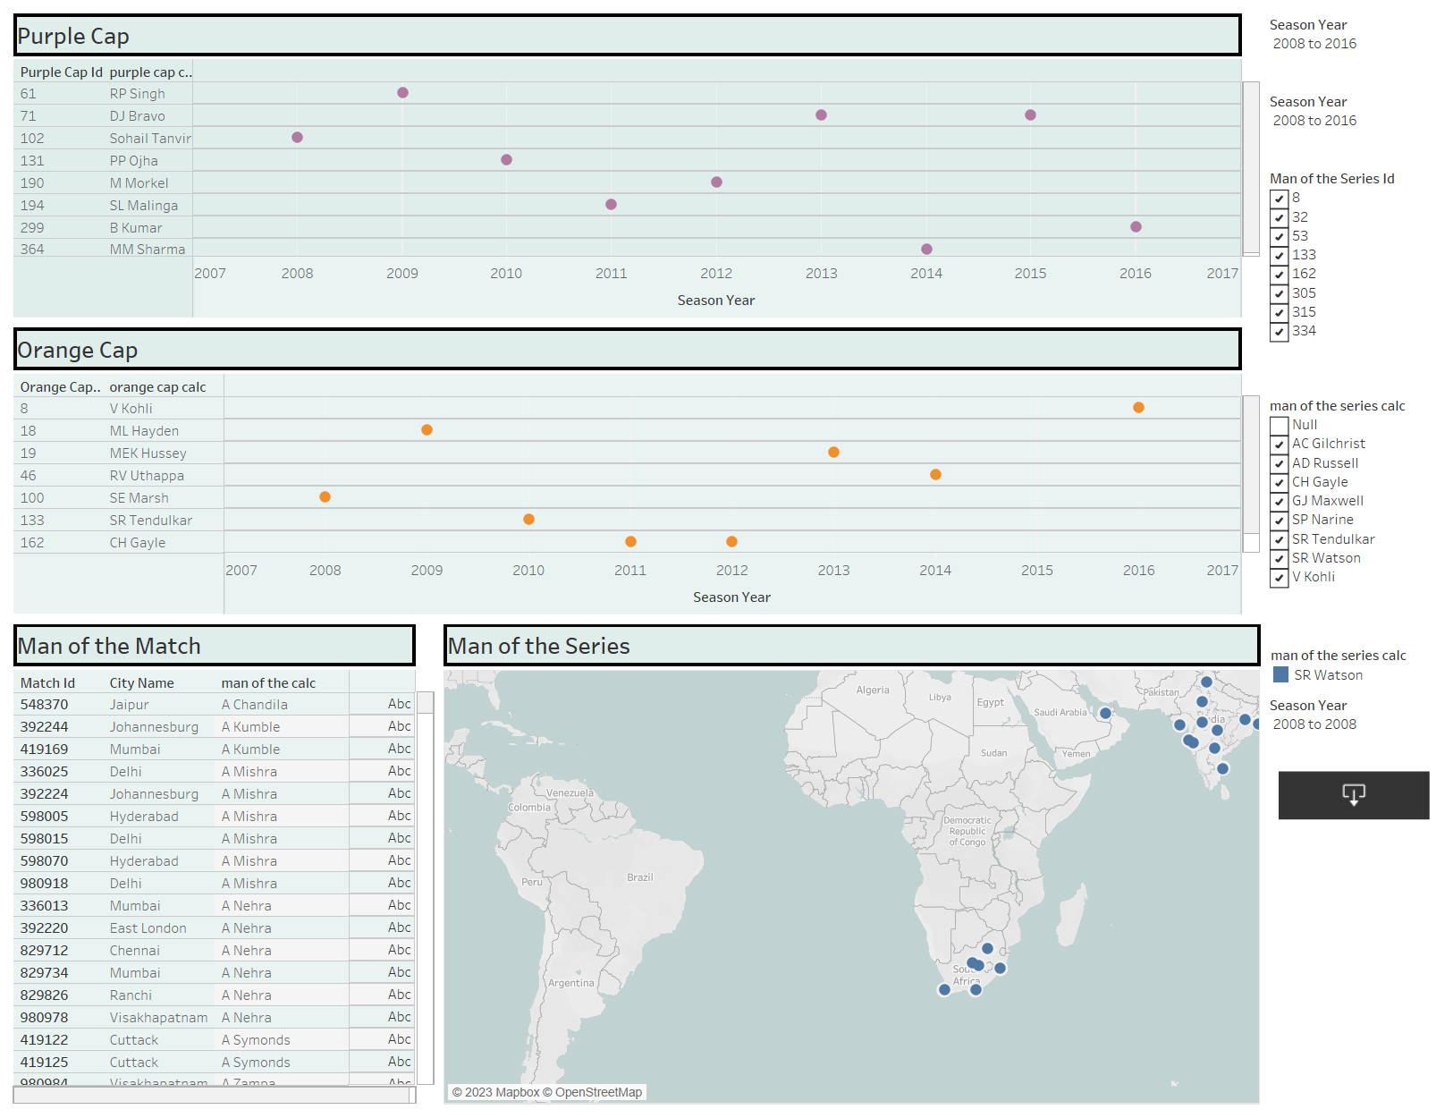

REFERENCES

1. ERL, T., KHATTAK, W., & BUHLER, P. (2016). BIG DATA FUNDAMENTALS: CONCEPTS, DRIVERS AND TECHNIQUES. BOSTON: PRENTICE HALL.

2. FRIENDLY, M. & DENIS, D. J. (2001). MILESTONES IN THE HISTORY OF THEMATIC CARTOGRAPHY, STATISTICAL GRAPHICS, AND DATA VISUALIZATION. RETRIEVED FROM HTTP://WWW.DATAVIS.CA/MILESTONES/

3. KNAFLIC, C. N. (2015). STORYTELLING WITH DATA: A DATA VISUALIZATION GUIDE FOR BUSINESS PROFESSIONALS. HOBOKEN, N.J.: WILEY

4. MELONCON, L., & WARNER, E. (2017). DATA VISUALIZATIONS: A LITERATURE REVIEW AND OPPORTUNITIES FOR TECHNICAL AND PROFESSIONAL COMMUNICATION. PAPER PRESENTED AT THE PROFESSIONAL COMMUNICATION CONFERENCE (PROCOMM), 2017 IEEE INTERNATIONAL, MADISON, WI, USA.
5. NATIONAL EYE INSTITUTE. (2015). FACTS ABOUT COLOR BLINDNESS. RETRIEVED FROM HTTPS://NEI.NIH.GOV/HEALTH/COLOR_BLINDNESS/FACTS_ABOUT
6.SHNEIDERMAN, B. (1996). THE EYES HAVE IT: A TASK BY DATA TYPE TAXONOMY FOR INFORMATION VISUALIZATIONS. PAPER PRESENTED AT THE PROCEEDINGS OF IEEE SYMPOSIUM ON VISUAL LANGUAGES BOULDER, COLORADO.
7.WARD, M. O., GRINSTEIN, G., & KEIM, D. (2015). INTERACTIVE DATA VISUALIZATION: FOUNDATIONS, TECHNIQUES AND APPLICATIONS.RETRIEVED FROM HTTP://EBOOKCENTRAL.PROQUEST.COM/LIB/UQL/DETAIL.ACTION?DOCID=1786691
8.WIKIPEDIA. (2017). INFORMATION VISUALISATION. RETRIEVED FROM HTTPS://EN.WIKIPEDIA.ORG/WIKI/INFORMATION_VISUALIZATION
9.WIKIPEDIA. (2017). SCIENTIFIC VISUALIZATION. RETRIEVED FROM HTTPS://EN.WIKIPEDIA.ORG/WIKI/SCIENTIFIC_VISUALIZATION

